Retrieved from The Telegraph. http://www.telegraph.co.uk/technology/2016/05/09/reading-on-computer-screens-changes-how-your-brain-works-scienti/

Reading on computer screens changes how your brain works, scientists say
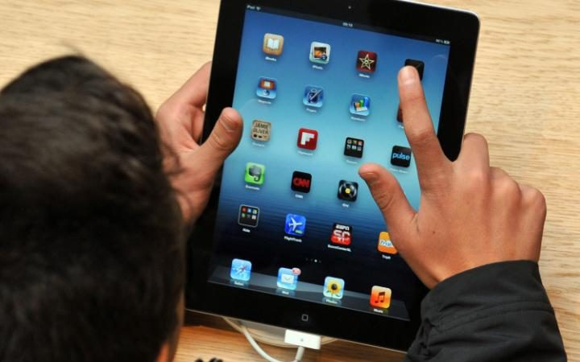
Computer and tablet screens are increasingly used for reading CREDIT: PA

By James Titcomb
9 MAY 2016 • 1:00PM

R
eading on computer screens and smartphones has made people unable to fully understand what they are reading as our brains retreat into focusing on small details rather than meanings, a study claims.
Researchers found that those who filled in forms, read short stories or studied using computer screens tended to grasp the basic facts of what they were reading, but often failed to process the “high-level” or abstract ideas behind the material.
The findings from Dartmouth College support common fears that modern technology has shortened attention spans and left little time for contemplative thought.
The authors suggested that the possibility of distractions offered by computers had caused people to resort to the less mentally-challenging activity of grasping concrete details when reading, even in the test conditions when these distractions were not available.
The study suggests that reading print allows people to better understand its meaningCREDIT: ALAMY
“The ever-increasing demands of multitasking, divided attention, and information overload that individuals encounter in their use of digital technologies may cause them to ‘retreat’ to the less cognitively-demanding lower end of the concrete-abstract continuum,” they wrote.
In the study, participants were asked to do a series of tasks, including filling in a form, reading a short story and comparing different car models, with the group split between those doing so on paper and on a computer screen.
It found that those performing tasks with paper were overwhelmingly more capable of interpreting the meaning of the material, while those using computers would retain particular details.
For example, when choosing between two ways to describe “making a list”, those answering on a computer would select “writing things down”, and those doing so on paper would choose “getting organised”.
In a comprehension test about a short story, those who had read it in print fared far better in questions about the story’s inferences and broader narrative, while those who had read the digital document retained more information about minor details.
When evaluating the specifications of four fictional cars, 66 per cent of those who had read the comparison on paper could correctly say which was the best model, against 43 per cent of those who had read it on a computer.
The researchers, due to present their findings at the ACM conference on human-computer interaction on Tuesday, said: “These results are not intended to be an indictment of digital technology and its impact on cognition… At the same time, if the increasing accessibility and ubiquity of digital technologies is causing a shift, it is important to consider the ramifications of this trend.”
FK 17. 8

Author: _________________________________
Publisher: _______________________________
Date of publication: ________________________

______________________________________________________________ _________________________________________________________ _________________________________________________________

